Exhibit C
W 17163

Long Beach Unit

THUMS Long Beach Company

(Agent for Field Contractor)

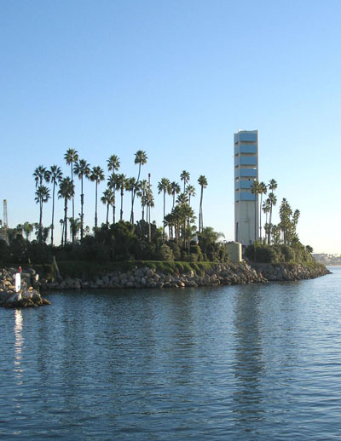

ANNUAL PLAN

July 1, 2009 through June 30, 2010

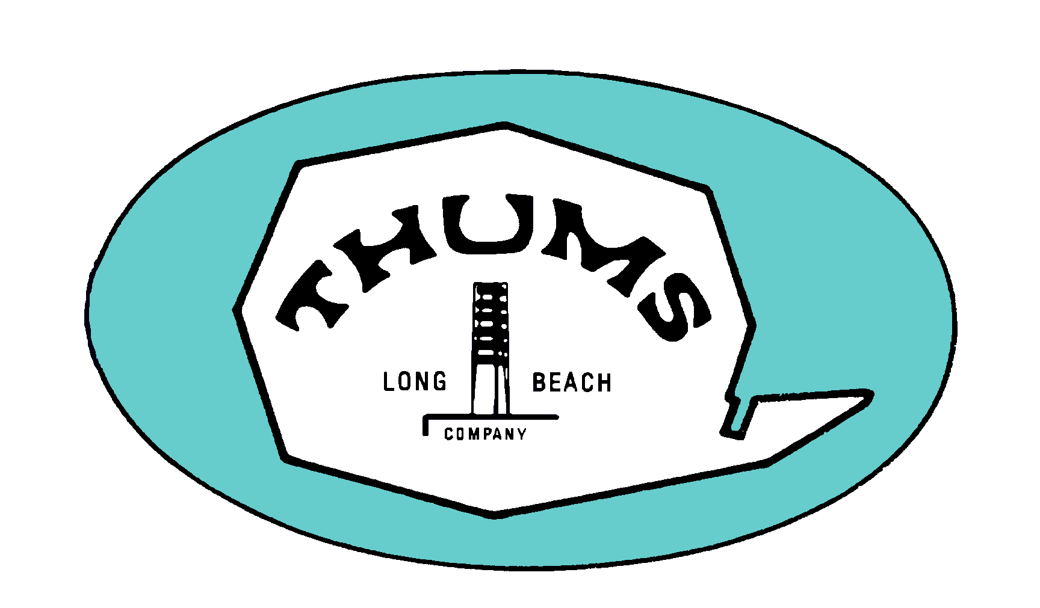

ANNUAL PLAN

July 1, 2009 through June 30, 2010

Table of Contents

Page
Part I - Introduction 2
A. Plan Basis 3
B. Economic Projections 5
C. Major Planning Assumptions 6

Part II – Program Plan Schedules 7
A. Range of Production and Injection Rates 7
B. Anticipated Development and Replacement Locations 8

Part III – Itemized Budget Expenditures 9
A. Development Drilling 9
B. Operating Expense 9
C. Facilities, Maintenance, and Plant 10
D. Unit Field Labor and Administrative 10
E. Taxes, Permits, and Administrative Overhead 11

PART IV - Definitions 12
A. Modifications 12
B. Supplements 12
C. Final Report and Closing Statement 13

Part I - Introduction

This Annual Plan (“Plan”) was developed to reflect anticipated activity levels during the fiscal period from July 1, 2009 through June 30, 2010 (“FY09/10”). It is being submitted as required by Section 5(a) of Chapter 138, Statutes of 1964, First Extraordinary Session, and as revised by passage of Assembly Bill 227 (Chapter 941, Statutes of 1991) and the Optimized Waterflood Program Agreement approved by the State of California, the City of Long Beach, and Atlantic Richfield Company, whose interest has been assigned to Occidental Petroleum Corporation.

This Plan provides for drilling, producing, water injection, and other associated activities from offshore and onshore locations. The budget for these activities is grouped into the following five major categories:

Plan Category | Fiscal Year  2009 – 2010  ($ Million)
Development Drilling | $ 74.0
Operating Expense | $ 103.8
Facilities, Maintenance, and Plant | $ 77.6
Unit Field Labor and Administrative | $ 52.8
Taxes, Permits, and Administrative Overhead | $ 42.0
Total | $ 350.2

A. Plan Basis

This Plan was developed based on the parameters outlined in the Program Plan for the period July 2009 through June 2014 and provides current estimates of volumes, drilling activity and expenditures for FY09/10. Expenditure levels and project mix will be adjusted as needed to respond to fluctuations in oil price and other economic conditions.

Volumes

Oil and gas production volumes are predicted to average 25.5 Mbopd and 12.6 MMcfpd, respectively, in FY09/10. Water production for the period is expected to average 955 Mbwpd and water injection is expected to average 1,039 Mbwpd.

Revenue and Expenses

A projected oil price of $40.00/bbl Wilmington and gas price of $6.00/mcf will result in revenues of $399.2 million. Budgeted expenses for FY09/10 total $350.2 million. Projected net profit in FY09/10 is $49.0 million.

Drilling

This Plan allows for drilling approximately 50 new and redrilled development and/or replacement wells. The plan is to use two drilling rigs for the FY09/10. Two workover rigs will perform drilling preparation and completion work. Locations of production and injection wells to be drilled or redrilled are given in Part II, Schedule 1B of this Plan.

Maintenance

Most of the major facility projects anticipated during the Plan period are required to maintain current equipment capabilities or to enhance operations. Other projects will be necessary to take advantage of improvement opportunities and to address changes in the oil field operating environment.

Many projects will be undertaken to repair or replace equipment that has outlived its useful life. Items needing to be repaired or replaced include, but are not limited to, facilities piping, tanks, and vessels. These projects are consistent with past activities to keep the Unit facilities in safe operating condition.

Abandonment

Wells and facilities with no further economic use will be abandoned to reduce current and future Unit liability. This Plan provides funds for plugging wells to surface, in-zone, and conditional abandonments with approximately $0.42 million in spending for the Plan period.

Safety, Environmental, and Regulatory Compliance

The Unit is committed to conducting all aspects of its business in a manner that provides for the safety and health of employees, contractors and the public, and safeguards the environment in which it operates. Projects relating to safety, environmental issues, or other situations necessary for meeting compliance with code, permit, or regulatory requirements will continue to be implemented under this Plan in accordance with all Unit agreements. In addition, Thums will be placing additional emphasis on risk and system reviews and operational safeguards to assure reliable and compliant environmental performance.

Economic Review

Project expenditures during the Plan period are subject to economic review through the Determination and Authority for Expenditure processes.

All existing wells are frequently reviewed in light of changing crude prices to determine if they are economic to operate. Well servicing work is justified on economics and other conditions consistent with good engineering, business, and operating practices.

B. Economic Projections

(Data in Millions of Dollars)
 | BUDGET FIRST QUARTER FY09/10 | BUDGET SECOND QUARTER FY09/10 | BUDGET THIRD QUARTER FY09/10 | BUDGET FOURTH QUARTER FY09/10 | BUDGET TOTAL FY09/10
ESTIMATED REVENUE
Oil Revenue | $95.5 | $94.5 | $90.2 | $91.5 | $371.7
Gas Revenue | $7.4 | $7.3 | $6.2 | $6.6 | $27.5
TOTAL REVENUE | $102.9 | $101.8 | $96.4 | $98.1 | $399.2
ESTIMATED EXPENDITURES
Development Drilling | $18.5 | $18.5 | $18.5 | $18.5 | $74.0
Operating Expense | $24.6 | $24.8 | $26.9 | $27.5 | $103.8
Facilities & Maintenance | $19.5 | $19.5 | $19.3 | $19.3 | $77.6
Unit Field Labor & Administration | $13.2 | $13.2 | $13.2 | $13.2 | $52.8
Taxes, Permits & Overhead | $10.5 | $10.5 | $10.5 | $10.5 | $42.0
TOTAL EXPENDITURES | $86.3 | $86.5 | $88.4 | $89.0 | $350.2
NET PROFIT | $16.6 | $15.3 | $8.0 | $9.1 | $49.0

C. Major Planning Assumptions

 | BUDGET | BUDGET | BUDGET | BUDGET
 | FIRST | SECOND | THIRD | FOURTH | BUDGET
 | QUARTER | QUARTER | QUARTER | QUARTER | TOTAL
 | FY09/10 | FY09/10 | FY09/10 | FY09/10 | FY09/10
OIL PRODUCTION
PRODUCED (1000 BBL) | 2,388 | 2,362 | 2,256 | 2,288 | 9,294
(AVERAGE B/D) | 25,956 | 25,671 | 25,067 | 25,138 | 25,461
GAS PRODUCTION *
PRODUCED (1000 MCF) | 1,232 | 1,213 | 1,036 | 1,105 | 4,586
(AVERAGE MCF/D) | 13,388 | 13,184 | 11,514 | 12,138 | 12,563
WATER PRODUCTION
PRODUCED (1000 BBL) | 89,548 | 88,564 | 84,601 | 85,782 | 348,495
(AVERAGE B/D) | 973,343 | 962,649 | 940,013 | 942,664 | 954,780
WATER INJECTION
INJECTED (1000 BBL) | 97,452 | 96,381 | 92,069 | 93,354 | 379,256
(AVERAGE B/D) | 1,059,256 | 1,047,619 | 1,022,985 | 1,025,870 | 1,039,056
OIL PRICE ($/BBL) | $40.0 | $40.0 | $40.0 | $40.0 | $40.0
GAS PRICE ($/MCF) | $ 6.0 | $ 6.0 | $ 6.0 | $ 6.0 | $ 6.0
* Includes Shallow Gas

Part II – Program Plan Schedules

Schedule 1 A
Range of Production and Injection
FY 2009/10

Long Beach Unit Program Plan, July 2009-June 2014

A. Range of Production and Injection Rates

FISCAL YEAR | RANGE OF PRODUCTION AND INJECTION RATES
 | OIL MBOPD |  |  | WATER MBWPD |  |  | GAS MMCFPD |  |  | INJECTION MBWPD
2009-10 | 24.6 | - | 26.0 | 928 | - | 974 | 10.8 | - | 13.6 | 1,007 | - | 1,060

FISCAL YEAR | RANGE OF INJECTION PRESSURES
 | TAR PSI | RANGER PSI | TERMINAL PSI | U. P./FORD PSI
2009-10 | UP TO 1500 | UP TO 2500 | UP TO 2500 | UP TO 3000

Schedule 1 B
Anticipated Development and Replacement Locations
Fiscal Year 09/10

Long Beach Unit Program Plan, July 2009-June 2014

B. Anticipated Development and Replacement Locations

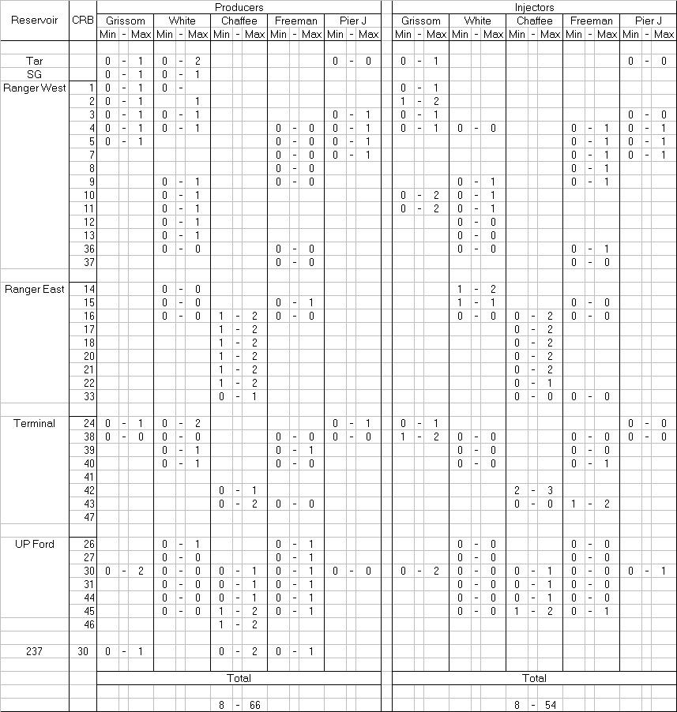

Part III – Itemized Budget Expenditures

A. Development Drilling $74,000,000

The Development Drilling Category of expenditures encompasses all new well and replacement well drilling activity, as well as maintenance and replacement of drilling equipment within the Unit. Funds for development drilling are based on the assumption that 50 wells will be developed and/or replaced during the Plan year, using approximately two drilling rigs.

Drilling and completing new wells, as well as redrilling and recompleting existing wells, account for 94 percent of the funding provided in this Category. Included in these activities is funding for rig move-in, drilling and casing, completion activities, drilling rig in-zone plugs and conditional abandonments, and unscheduled activity (fishing operations, cement squeezing, special logging, contract drilling services).

Exact specifications regarding the distribution of wells, bottom hole locations, and completion intervals will be determined by OXY Long Beach, Inc. (OLBI). These decisions will be influenced by contributions from reservoir engineering personnel, results from ongoing engineering studies, and new well performance. This information will be reviewed and approved in accordance with Unit Agreements during regularly scheduled Unit forums.

B. Operating Expense $103,800,000

The Operating Expense Category of expenditures encompasses the ongoing costs of day-to-day well production and injection operations necessary for producing, processing, and delivering crude oil and gas, and for all electric power charges. Expenses for this Category are based on estimated oil production of 25.5 Mbopd, estimated gas production of 12.6 MMcfpd, water injection requirement of 1,039 Mbwpd, and water production of 955 Mbwpd. Anticipated operating expenses were based on operating three maintenance workover rigs per month for servicing an average active well count of 871 producers and 484 injectors. Abandonment well count will be determined as a function of drilling activity and the number of idle wells with no future use.

The day-to-day costs for production and injection well subsurface operations represent approximately 36 percent of the funding provided in this Category. Included are funds for acidizing, fracturing, routine well work, well conversions, in-zone plugs, conditional abandonments, and other charges incurred for well maintenance.

Electricity makes up 60 percent of the funds in this Category. Cost for electric power is based on estimated kilowatt usage of 669,559,000 kwh at an average rate of $0.092/kwh. This cost includes all sources of Unit electrical power, including all costs associated with the power plant and electric utility purchases.

C. Facilities, Maintenance, and Plant $77,600,000

The Facilities, Maintenance, and Plant Category of expenditures encompasses costs for maintenance, repairs, upgrades, additions of surface facilities and pipelines, and costs for general field services.

Approximately 50 percent of the funding in this Category is for general field and operating costs. This includes, but is not limited to, charges for general labor, equipment rentals, and materials for general maintenance (painting, welding, electrical, etc.) of all Unit systems, such as oil gathering, treating, storage, and transfer; gas gathering and treating; scale and corrosion control; produced water handling; waste disposal; leasehold improvements; electrical system; fresh water system; fire protection and safety; marine operations; and automotive equipment. Funds are also provided for chemical purchases and laboratory-related charges for chemical treatment of produced and injected fluids; gas processing charges; make-up water; security; transportation; small tools; and other miscellaneous field activities.

Approximately 50 percent of the funding in this Category is for facilities repair and improvement projects. Improvement projects may include spending for the facility capacity limits expansion, waste disposal, pipeline replacements, and other infrastructure related investments that position the Unit for longevity.

D. Unit Field Labor and Administrative $52,800,000

The Unit Field Labor and Administrative Category of expenditures encompasses costs for Unit personnel and other Unit support activities.

Funding for Unit personnel includes costs of salaries, wages, benefits, training, and expenses of all Thums employees. These costs represent approximately 80 percent of the Category total.

Funding for Unit support activities includes, but is not limited to, costs for professional and temporary services necessary for the completion of support activities; charges for data processing; computer hardware and software; communications; office rent; general office equipment and materials; Unit Operator billable costs; OLBI billable costs; drafting and reprographic services; Department of Transportation drug and alcohol testing; special management projects; and other miscellaneous support charges.

E. Taxes, Permits, and Administrative Overhead $42,000,000

The Taxes, Permits, and Administrative Overhead Category of expenditures includes funds for specific taxes, permits, licenses, land leases, and all administrative overhead costs for the Unit.

Funding is provided for taxes levied on personal property, mining rights, and oil production; for the Petroleum and Gas Fund Assessment; annual well permits and renewals; Conservation Committee of California Oil and Gas Producers Assessment; California Oil Spill Response, Prevention, and Administration fee; land leases; and pipeline right-of-way costs. These costs represent approximately 66 percent of the Category total.

Funding is also provided in this Category for all Administrative Overhead as called for in Exhibit F of the Unit Operating Agreement.

PART IV - Definitions

This Annual Plan may be Modified or Supplemented after review by the State Lands Commission for consistency with the current Program Plan. All Modifications and Supplements to this plan will be presented by the Long Beach Gas and Oil Department, City of Long Beach, acting with the consent of OLBI, to the State Lands Commission in accordance with Article 2.06 of the Optimized Waterflood Program Agreement.

In addition, on or before October 1, 2010 the City of Long Beach shall present to the State Lands Commission a final report and closing statement of the FY09/10 Annual Plan, in accordance with the provision in Section 10 of Chapter 138.

A. Modifications

The City of Long Beach, acting with the consent of OLBI, has the authority to cause the expenditures of funds for Unit Operations in excess of the amount set forth in the budget included in the Annual Plan, provided, however, that no such expenditure shall be incurred that would result in any category of expenditures set forth in the budget to exceed 120 percent of the budgeted amount for that category. A budget modification would be required for any expenditures which would cause a budget category to exceed its budgeted amount by 120 percent.

Any transfer of funds between budget categories or an augmentation or decrease of the entire budget may be accomplished by a budget modification in accordance with section 5(g) of Chapter 138 and Article 2.06 of the Optimized Waterflood Program Agreement.

Investment, facilities, and management expense projects commenced in prior budget periods, which are to be continued during the current budget period, may be added to this budget by a modification in accordance with Article 2.06 of the Optimized Waterflood Program Agreement.

B. Supplements

This Annual Plan contains all the investment and expense projects reasonably anticipated at the time the Plan was drafted and for which adequate detailed studies existed. Any significant and uncommon expenses not originally contemplated may be added to this budget or transferred by a supplement in accordance with Article 2.06 of the Optimized Waterflood Program Agreement. The amount of the supplement shall include sufficient funds to complete the projects.

C. Final Report and Closing Statement

The final report and closing statement for FY09/10 shall contain a reconciliation by category as finally modified and the actual accomplishments, including:

1. New wells and redrills by zone.

2. Facilities and capital projects.

3. Production by zone.

4. Injection by zone.

