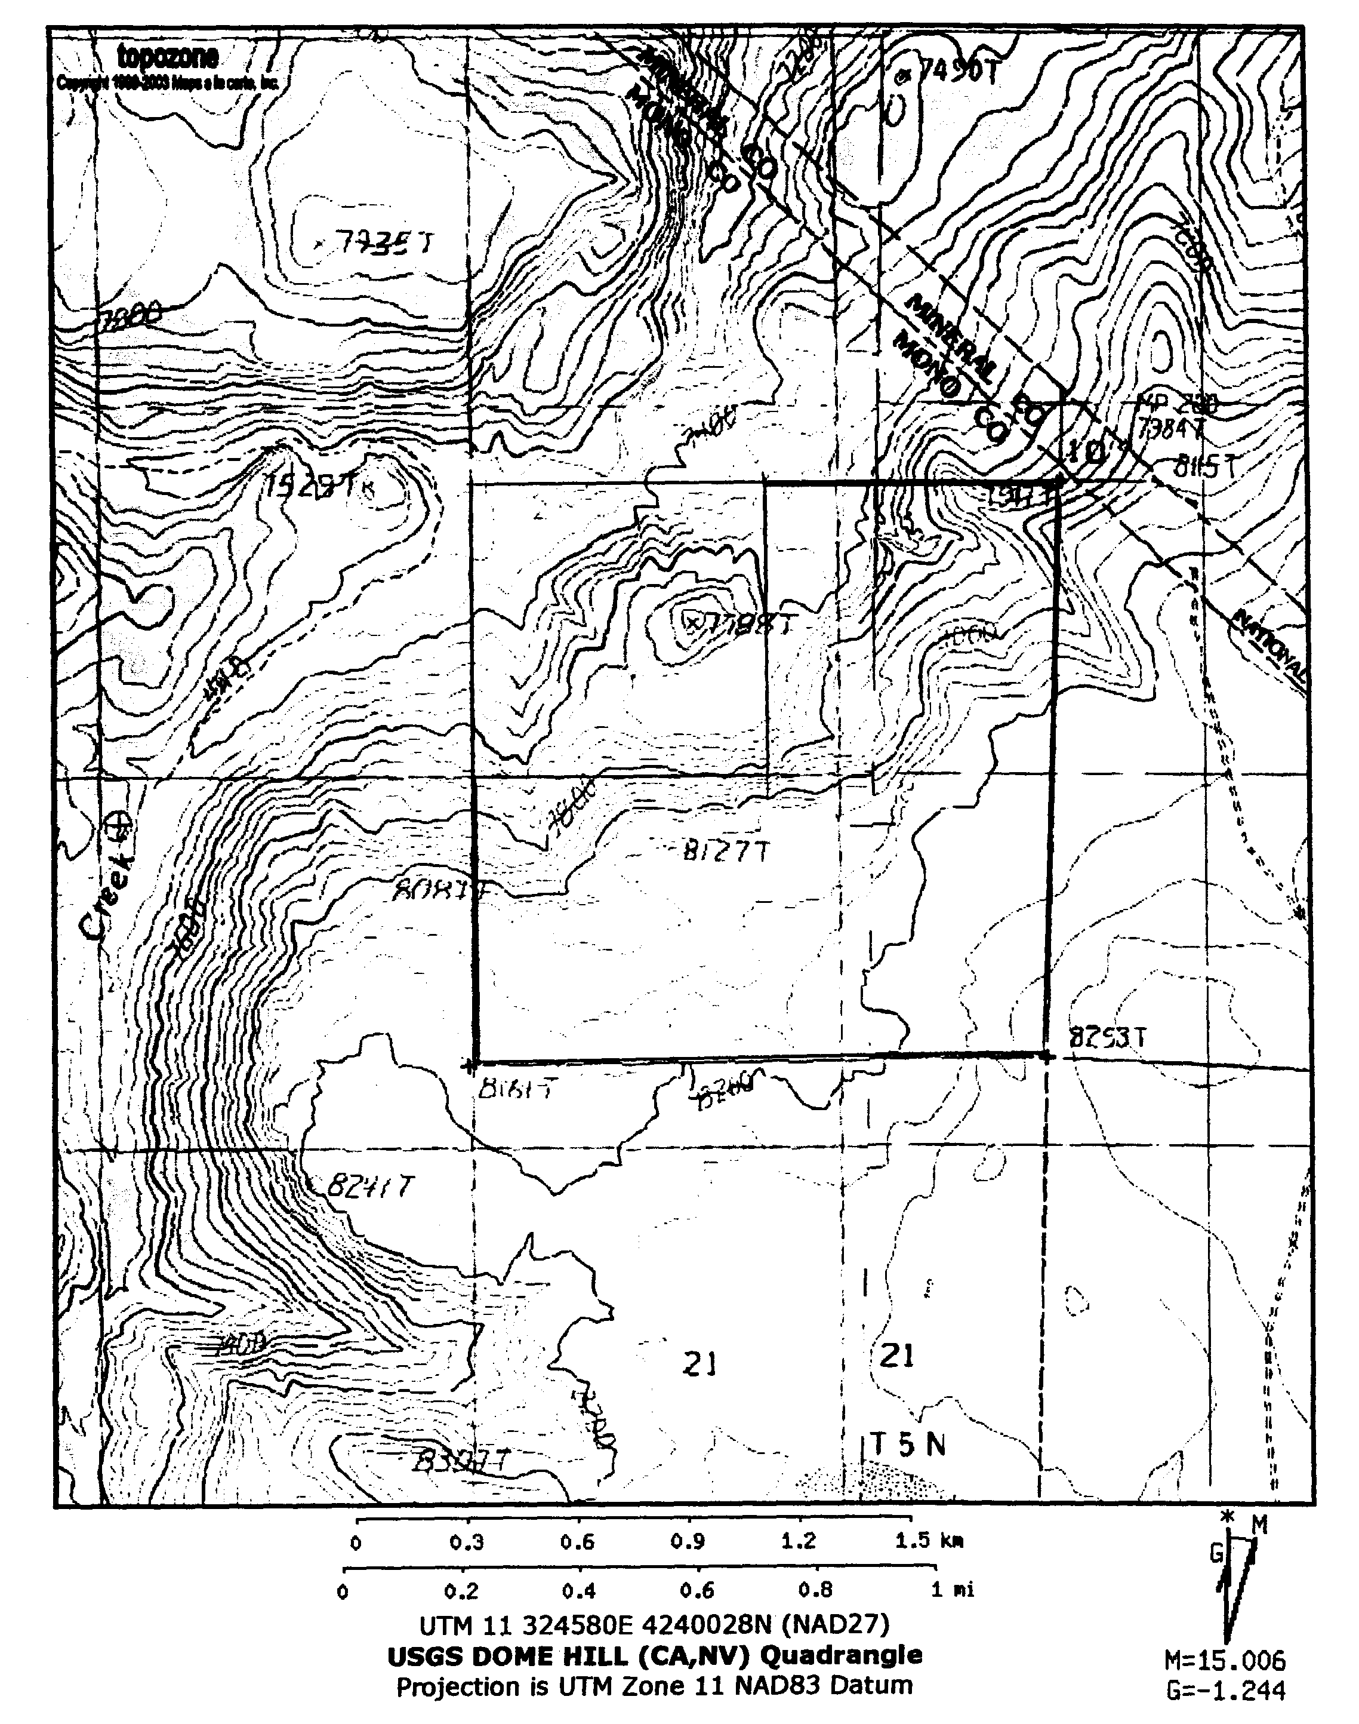

PRC 8742.2

**LOCATION MAP**

**EXHIBIT A**